|  |  |
| --- | --- |
| Logo UNIMAS | **UNIVERSITI MALAYSIA SARAWAK**  **Faculty of Computer Science and Information Technology** |

# Assignment/Report Cover Sheet

|  |  |  |  |
| --- | --- | --- | --- |
| **Student Name** | **Student ID Number** | **Group No** | **Signature** |
| Mirza Muhammad Bin Munshee | 82669 | G02 |  |
| Robbie Samir Anak Bruno | 85556 | G02 |  |
| Javier Miguel Abeng | 84110 | G02 |  |
| Azeleen Jane Romanus | 83340 | G02 |  |
| Christine Yong Sze Teng | 82491 | G02 |  |

|  |  |  |  |  |
| --- | --- | --- | --- | --- |
| Subject Code: **TMA3084** | | Subject Name : **Software Engineering Lab** | | |
| Assignment Title: | **User Manual** | | Lecturer: | **Ts. Nurfauza Jali** |
| Due Date: **9th** **January 2025** | | | Date Submitted: **9th** **January 2025** | |

This cover sheet must be completed, signed and firmly attached to the front of the submission. All work must be submitted by the due date. If an extension of work is granted, an assignment extension acknowledgement slip must be signed by the lecturer/tutor and attached to assignment. Please note that is your responsibility to retain copies of your assignment.

|  |
| --- |
| ***Plagiarism and Collusion are methods of cheating that falls under Peraturan Akademik Universiti Malaysia Sarawak para 11: Etika Akademik***  **Plagiarism**  Plagiarism is the presentation of work which has been copied in whole or in part from another person’s work, or from any other source such as the internet, published books or periodicals without due acknowledgement given in the text.  **Collusion**  Collusion is the presentation of work that is the result in whole or in part of unauthorized collaboration with another person or persons.  Where there are reasonable grounds for believing that cheating has occurred, the only action that may be taken when plagiarism or collusion is detected is for the staff member not to mark the item of work and to report or refer the matter to the Dean. This may result in work being disallowed and given a fail grade or if the circumstances warrant, the matter may be referred to a Committee of inquiry for investigation. Such investigation may result in the matter being referred to the University Discipline Committee, **which** has the power to exclude a student. |

|  |
| --- |
| **Upon placing signature above, I certify that I have not plagiarized the work of others or participated in unauthorized collusion when preparing this assignment.**  **I also certify that I have taken proper case in safeguarding my work and have made all reasonable efforts to ensure that may work not be able to be copied.** |

|  |
| --- |
| **MARK :** |

**User Manual for Wedding Planner Mobile Application (Wedding2U)**

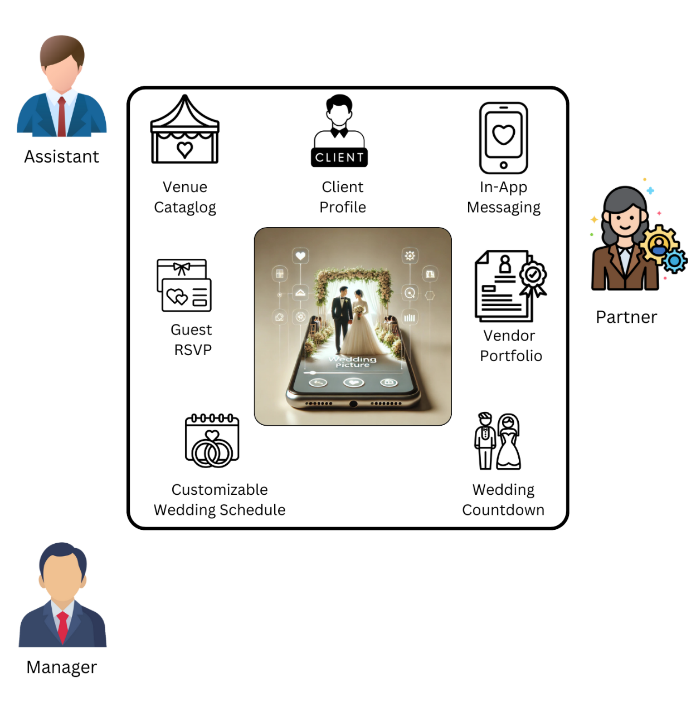

|  |  |
| --- | --- |
|  | The Wedding Project logo with a diamond. |

Table of Contents

Assignment/Report Cover Sheet 1

1.0 Registration 4

1.1 Sign in 5

2.0 Client features 6

2.1 Client Dashboard 6

2.2 Venue Catalog and Booking 7

2.3 Manage Wedding 8

2.4 Clients Post and Review 9

2.5 Select a Vendor by category 10

2.6 Manage Profile 12

3.0 Vendor features 14

3.1 Vendor Dashboard 14

3.2 Manage Your Portfolio 15

3.3 Vendor’s Edit Profile 16

3.4 Manage service request 17

4.0 Admin features 18

4.1 Admin Dashboard 18

4.2 Manage Venue catalog 19

4.3 Manage Venue Bookings 21

4.4 Moderate Review Posts 22

5.0 Guest features 23

5.1 Guest Invitation codes 23

5.2 Confirmation of invitation 24

5.3 Guest Dashboard 25

# 1.0 Registration

|  |  |
| --- | --- |
|  |  |

Upon launching the app, users are directed to the “Sign Up As” screen, where they can choose their role which is Client, Vendor or Admin. After selecting a role, they are navigated to a registration form tailored to their choice, featuring fields for name, phone number, email, password, and password confirmation, with an option to toggle password visibility. Users can complete the registration by tapping the “Create an account” button. Alternatively, they can select “Already have an account?Sign In” to log in or “Continue as Guest” to explore the app without registering. The registration flow is consistent and user-friendly across all roles.

# 1.1 Sign in

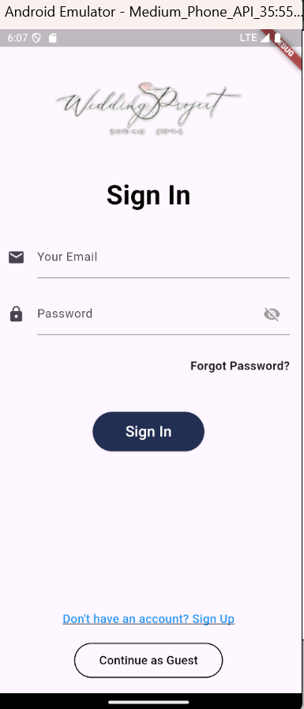

After completing the registration, users can access their accounts through the Sign In page. This page requires users to enter their registered email and password in the respective fields. Password visibility can be toggled using the eye icon. If users forget their password, they can tap the “Forgot Password?” link to initiate the recovery process. For new users, the “Don’t have an account”?The "Sign Up” link redirects them to the registration page, while the “Continue as Guest” option allows access without signing in. Tapping the “Sign In” button logs users into their account.

# 2.0 Client features

## 2.1 Client Dashboard

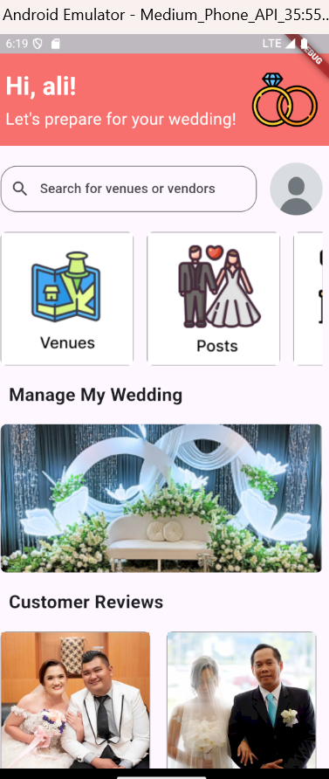

After logging in as a client, users are welcomed to the Dashboard with a personalized greeting and the message, "Let's prepare for your wedding!" At the top of the page is a search bar that allows users to search for venues or vendors. Below this, there is a horizontal scrollable section with quick access to features such as Venues, Posts, and Vendors. Swiping left or right reveals additional options. The dashboard also includes a section titled Manage My Wedding, which provides a visual entry point to wedding planning tools or features tailored for the user's event. Further down, the Customer Reviews section showcases images and feedback from past users, offering insights into the experiences of other clients.

## 2.2 Venue Catalog and Booking

|  |  |
| --- | --- |
|  |  |

From the Dashboard, selecting the Venues option navigates users to a list of venue packages. Each package displays an image, the venue name, a brief description, guest capacity, and a rating. For example, packages such as "Jawhara Package" or "Baitumal Package" include details like guest limits and highlights of the venue. Users can scroll through the options and select their preferred package.

Upon selecting a venue package, users are directed to the Venue Details page. This page provides additional information about the package, such as available services and features. Users can choose a booking date via a calendar input and proceed by clicking the "Book Venue" button.

## 2.3 Manage Wedding

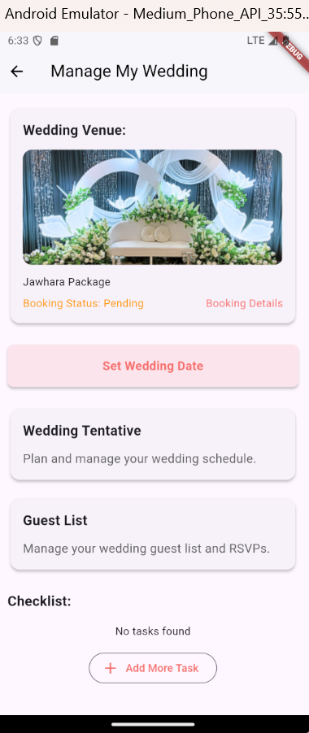

In the Manage My Wedding section, users can oversee all aspects of their wedding planning in one convenient location. The top of the page displays the selected Wedding Venue with details about the package and its current Booking Status. Users can tap "Booking Details" for more information about their reservation.

Below the venue information, clients can find options to:

* Set Wedding Date: Define the official date of the wedding.
* Wedding Tentative: Plan and manage the wedding schedule, ensuring all events are organized.
* Guest List: Manage the list of wedding guests, track RSVPs, and ensure accurate attendance.

At the bottom of the section, there is a Checklist where users can add specific wedding planning tasks by tapping the "Add More Task" button, helping them keep track of their to-dos.

## 2.4 Clients Post and Review

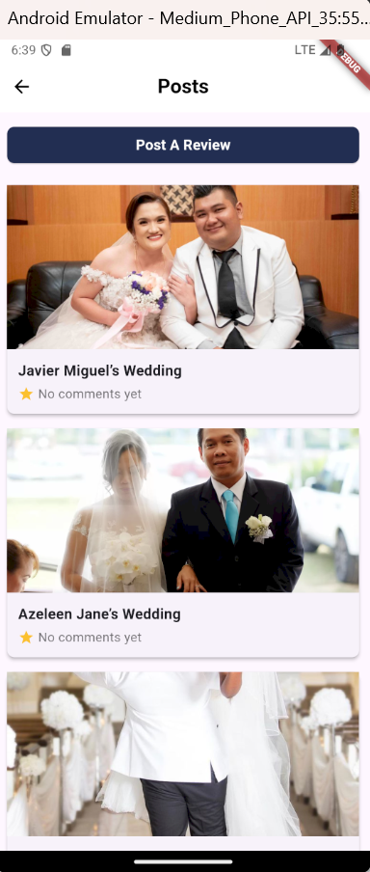

In the Posts section, users can explore shared wedding stories and experiences. At the top of the page, there is a "Post A Review" button, allowing users to share their own wedding experiences or provide feedback about venues or services. Below this, a list of posts is displayed, each featuring an image, the couple's name, and a short description.

## 2.5 Select a Vendor by category

|  |  |
| --- | --- |
|  |  |
|  |  |

In the Vendors section, users can explore various service categories to find and book vendors for their wedding. The main page displays three categories with images for easy identification:

* Photographers: Capture memorable moments with professional photography services.
* Make-Up Artists: Book experts for bridal makeup and styling.
* Caterers: Find caterers to provide delicious meals for the event.

Selecting a category leads to a detailed list of vendors under that service. Each vendor card includes:

* Vendor Name: The name of the service provider
* Service Category: The type of service offered
* Location: The city or area where the vendor is based.

Users can browse through the available vendors, compare options, and proceed to book their preferred service provider, streamlining the process of assembling their dream wedding team.

## 2.6 Manage Profile

|  |  |
| --- | --- |
|  |  |

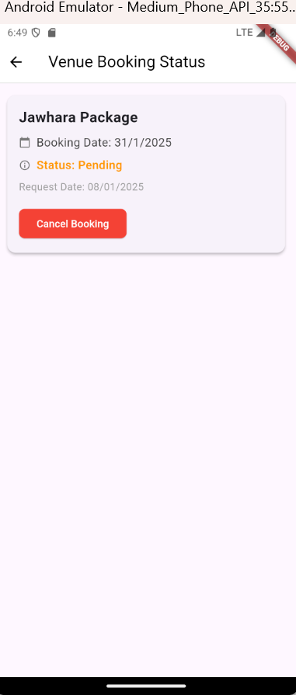

Tapping the Profile icon directs users to their personalized Profile page. At the top, users can view their profile picture, name, and other details such as location or contact information. Below, options are available to:

* Edit Profile: By selecting this button, users can update their details, including name, email, phone number, date of birth, country/region, and links to social media accounts. After making changes, users can save them by tapping the "Save Changes" button.
* View Booking Status: This redirects users to a page displaying their current venue booking details, such as the package name, booking date, status (e.g., pending), and request date. Users can take actions like canceling the booking by tapping the "Cancel Booking" button if necessary.

At the bottom of the Profile page, users can choose to Log Out, which signs them out of their account.

# 3.0 Vendor features

## 3.1 Vendor Dashboard

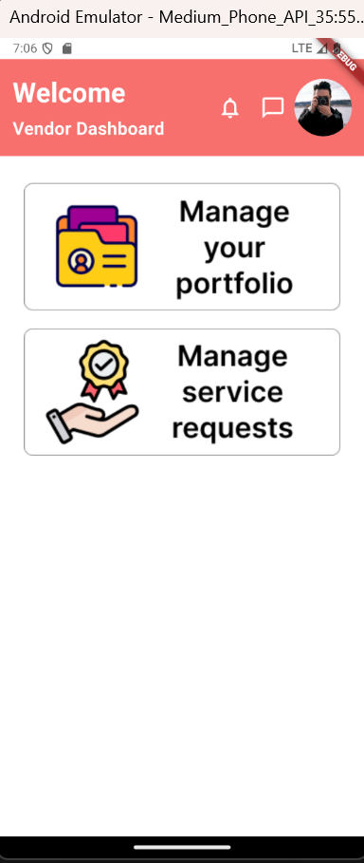

When vendors sign in, they are greeted with the Vendor Dashboard, which serves as a central hub for managing their services. The page includes two main sections:

* Manage Your Portfolio: Vendors can access and update their service portfolio, including details about their offerings, images, and descriptions to attract clients.
* Manage Service Requests: Vendors can view and manage client service requests, including bookings, inquiries, or pending actions.

The dashboard is designed for vendors to efficiently oversee their business operations and interact with clients directly through the platform.

## 3.2 Manage Your Portfolio

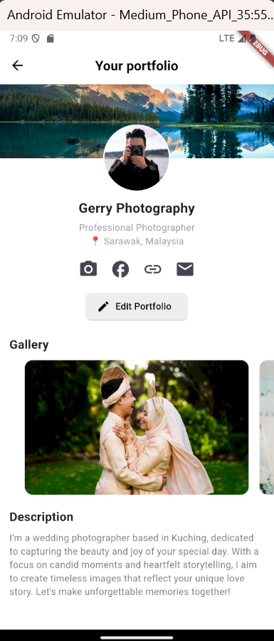

Selecting the Manage Your Portfolio option takes vendors to their personalized portfolio page, which showcases their professional profile. The page includes:

* Profile Header: Displays the vendor's name, their role, and location.
* Profile Image and Links: Shows the vendor's profile picture and icons for accessing social media or external links related to their business.
* Edit Portfolio Button: Allows vendors to update their portfolio, including profile details, images, or descriptions.

Below this, the Gallery section highlights images of the vendor's work, offering potential clients a glimpse of their services. The Description section provides a brief narrative about the vendor's expertise, style, and unique value proposition.

## 3.3 Vendor’s Edit Profile

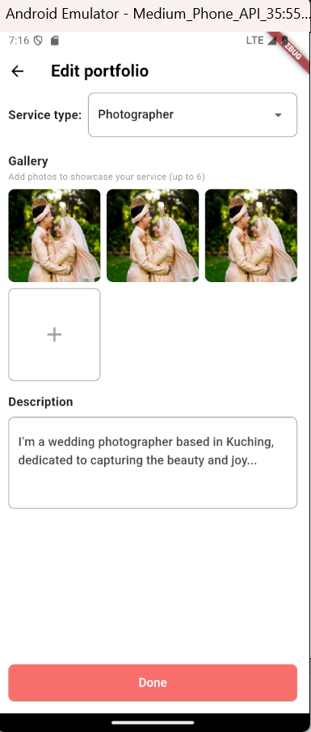

When vendors tap the Edit Portfolio button, they are taken to a page where they can update and refine their portfolio. This page includes:

* Service Type Dropdown: Allows vendors to select their service category.
* Gallery Section: Vendors can upload or update images to showcase their work, with a limit of six photos.
* Description Field: Vendors can craft or revise a brief narrative about their services, expertise, and what makes them unique.

After making changes, vendors can finalize their updates by tapping the Done button. This page provides vendors with the tools to maintain an appealing and current portfolio for potential clients.

## 3.4 Manage service request

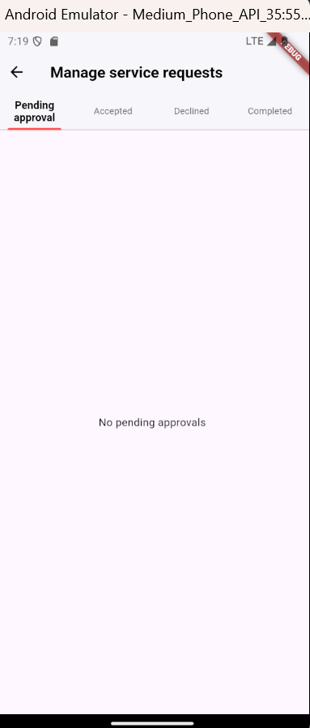

Upon selecting the Manage Service Requests section, vendors are directed to a page that organizes client service requests into four tabs for streamlined management:

* Pending Approval: Displays requests awaiting the vendor's response or decision.
* Accepted: Lists service requests that the vendor has approved.
* Declined: Shows requests that the vendor has declined.
* Completed: Tracks requests that have been fulfilled or completed.

# 4.0 Admin features

## 4.1 Admin Dashboard

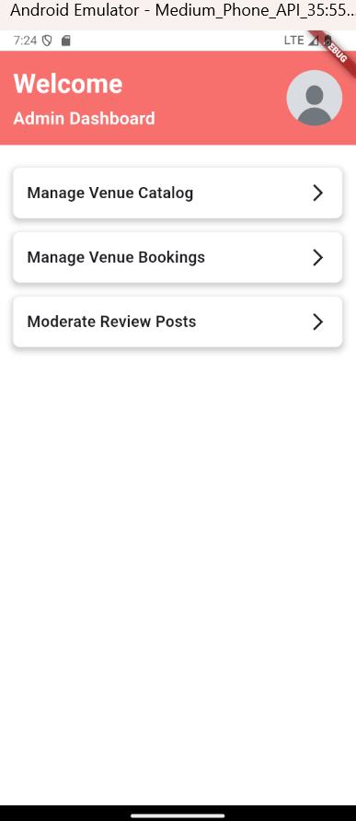

After signing in as an Admin, users are directed to the Admin Dashboard, which provides tools for managing the platform's core functionalities. The dashboard includes the following options:

1. Manage Venue Catalog: Allows admins to add, update, or remove venues and their details in the catalog, ensuring the information is up-to-date and accurate.
2. Manage Venue Bookings: Provides access to oversee all venue bookings, including pending, confirmed, and canceled reservations, for efficient tracking and resolution.
3. Moderate Review Posts: Enables admins to review, approve, or remove user-submitted reviews and posts, maintaining the platform's content quality and relevance.

This dashboard is designed for admins to seamlessly manage and moderate platform operations, ensuring a smooth experience for all users.

## 4.2 Manage Venue catalog

|  |  |
| --- | --- |
|  |  |
|  |  |

The Manage Venue Catalog section allows admins to oversee venue listings, providing tools to add, edit, or remove venues.

* Venue List: Upon entering the section, admins see a list of venues displayed with their name, description, guest capacity, and rating. Tapping on a venue opens its details page.
* Venue Details Page: This page provides an overview of the selected venue, including its name, description, and package details. Admins can tap the Edit Venue Details button to modify the information.
* Edit Venue Details: Admins can update the venue's name, description, and package details. Options include:
  + Save Changes: Applies the updates to the venue.
  + Delete Venue: Permanently removes the venue from the catalog.
  + Cancel: Discards change and return to the venue details page.
* Add Venue: Admins can add new venues by tapping the "+" button in the bottom-right corner. This opens the Add Venue form, where they can input the venue name, description, and package details. Tapping the Save button adds the new venue to the catalog.

## 4.3 Manage Venue Bookings

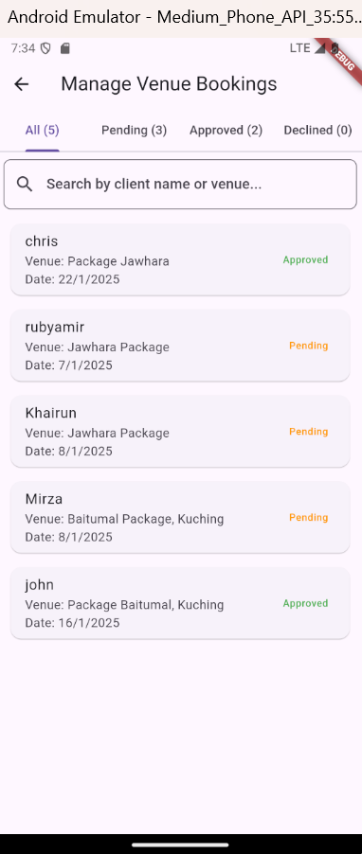

The Manage Venue Bookings section allows admins to oversee and track all venue booking requests. The page includes the following features:

1. Tab Navigation: Bookings are organized into four tabs for easy management:
   * All: Displays all bookings regardless of status.
   * Pending: Shows bookings that are awaiting admin approval.
   * Approved: Lists bookings that have been confirmed by the admin.
   * Declined: Contains bookings that have been rejected.
2. Search Function: A search bar at the top allows admins to quickly locate bookings by client name or venue.
3. Booking Details: Each booking display:
   * Client Name: The name of the individual who made the booking.
   * Venue: The venue and package booked.
   * Date: The scheduled date of the booking.
   * Status: The current status of the booking.

This section provides admins with a streamlined way to monitor and manage all venue bookings, ensuring smooth workflow and efficient communication with clients.

## 4.4 Moderate Review Posts

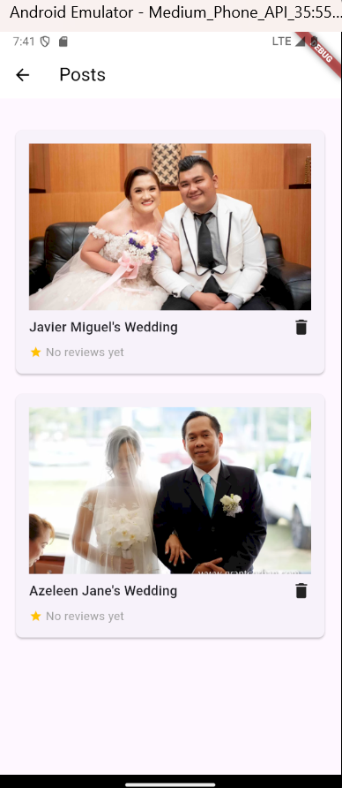

In the Moderate Review Posts section, admins can review and manage user-submitted posts related to weddings. Each post includes:

* Title: The name of the wedding or event.
* Thumbnail Image: A preview photo representing the wedding post.
* Review Status: Indicates if the post has received reviews.
* Trash Icon: Allows admins to delete inappropriate or irrelevant posts by tapping the trash icon.

# 5.0 Guest features

## 5.1 Guest Invitation codes

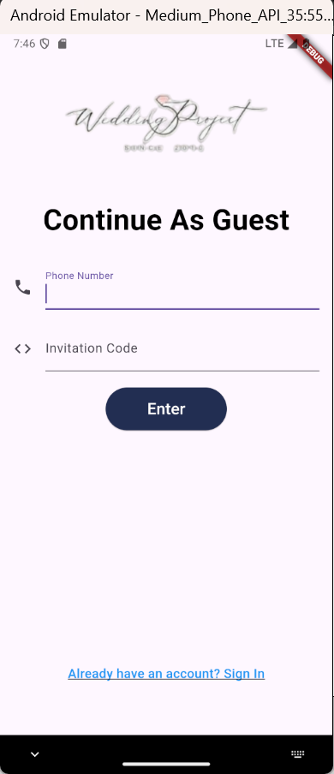

The Continue As Guest feature allows users to explore the platform without creating an account. To proceed, users are required to:

* Enter Phone Number: Provide a valid phone number for verification or communication purposes.
* Enter Invitation Code (if applicable): Input a code if required to access specific events or features.

Once the information is filled in, users can tap the Enter button to proceed. At the bottom, there is an option to Sign In for users who decide to register or log in instead. This feature provides quick and limited access for users who wish to browse or explore without a full account.

## 5.2 Confirmation of invitation

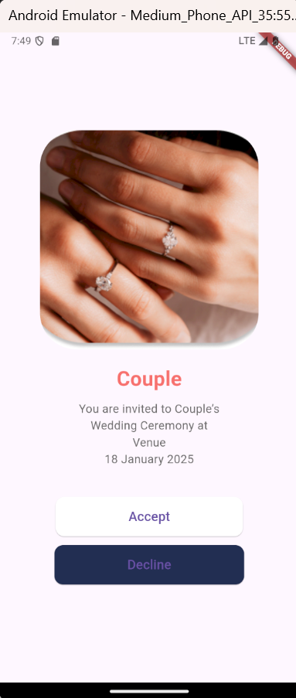

After entering the phone number and invitation code, guests are directed to the Invitation Confirmation page. This page displays:

* Image: A decorative or personalized image related to the event.
* Invitation Details: Includes the event name, venue, and date of the event.
* Action Buttons:
  + Accept: Confirms attendance at the event.
  + Decline: Declines the invitation.

This page provides a simple and user-friendly interface for guests to respond to their wedding invitations quickly and efficiently.

## 5.3 Guest Dashboard

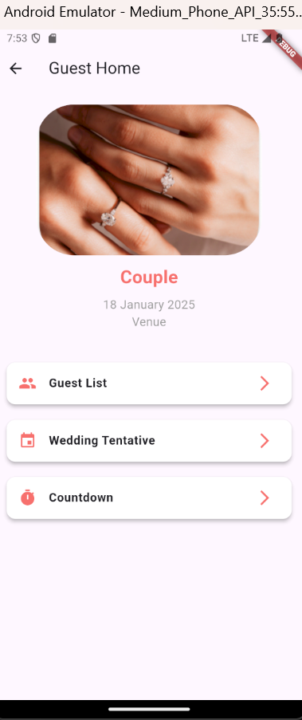

After accepting the invitation, guests are directed to the Guest Home page. This page provides event details and tools to manage the guest's participation in the wedding. It includes:

* Event Header: Displays an image, the event name, date, and venue.
* Navigation Options:
  1. Guest List: Allows guests to view the list of attendees for the event.
  2. Wedding Tentative: Provides access to the event's schedule, helping guests stay informed about the ceremony's timeline.
  3. Countdown: Displays a countdown timer leading up to the event date, adding excitement and helping guests keep track of the time remaining.